**Assignment - 1**

• Install Power BI Desktop and share the final screenshot of the report view page which appears when power desktop starts.

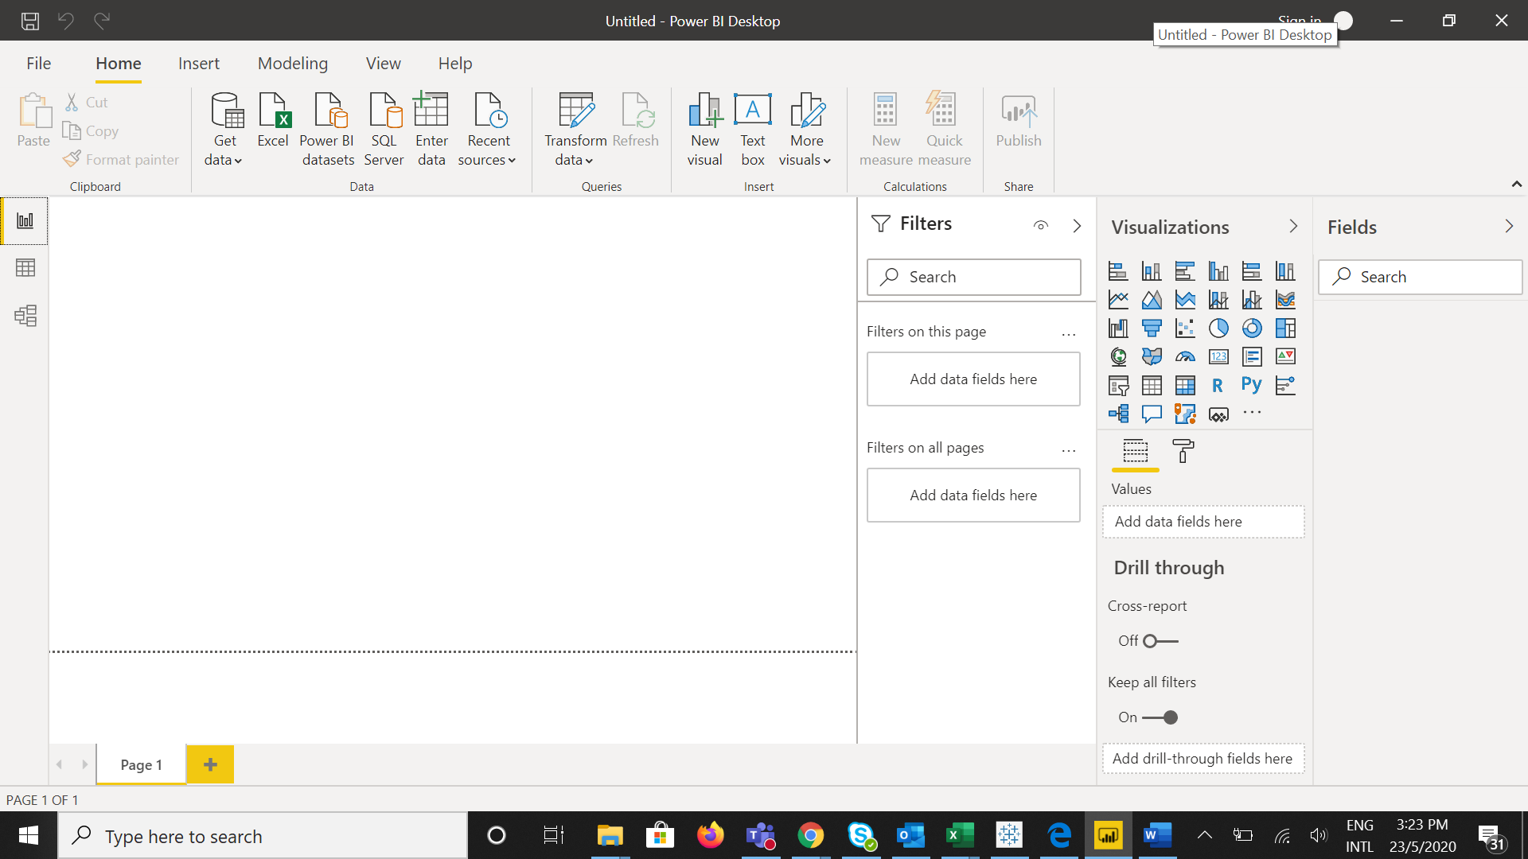

• Prepare a document and with the following screenshot

**− Report View**

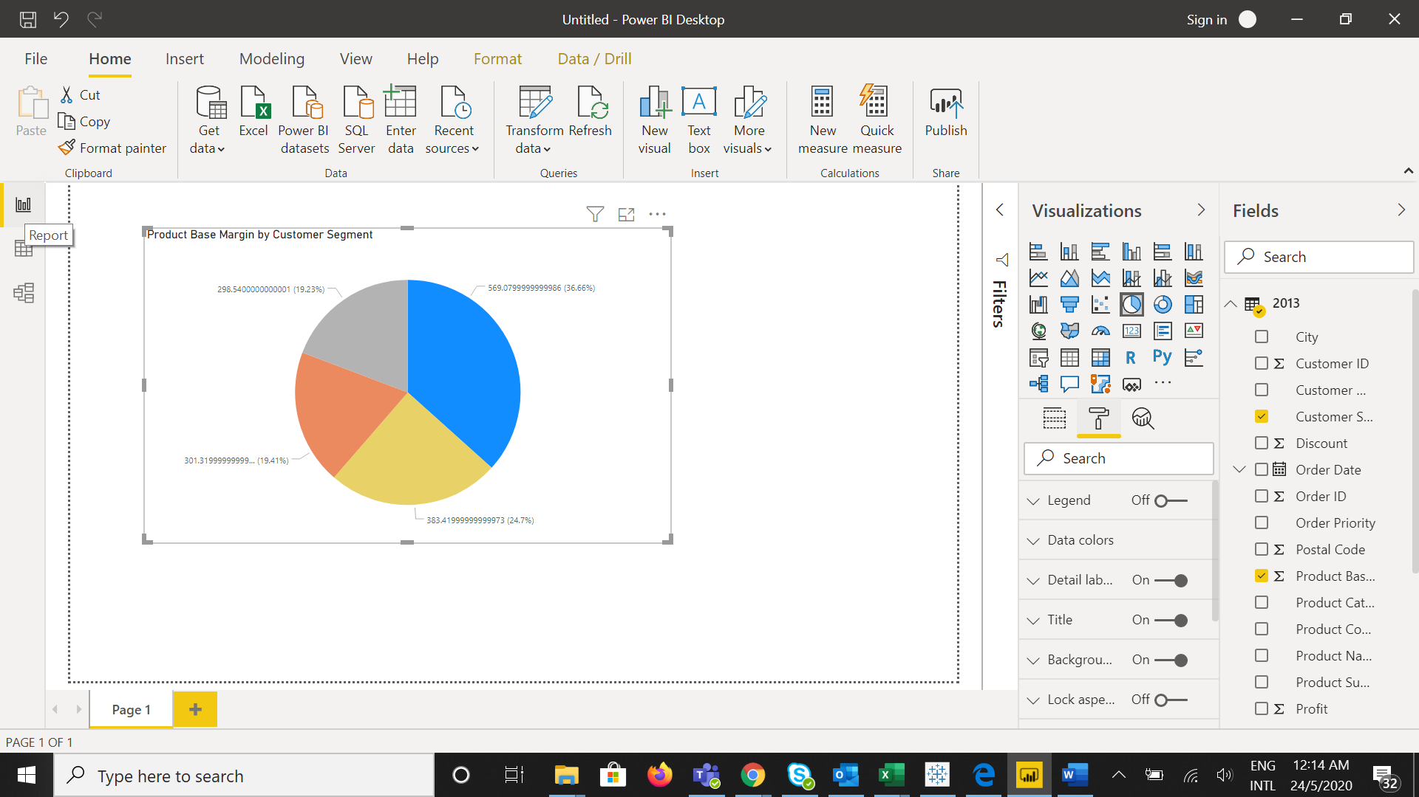

**− Data View**

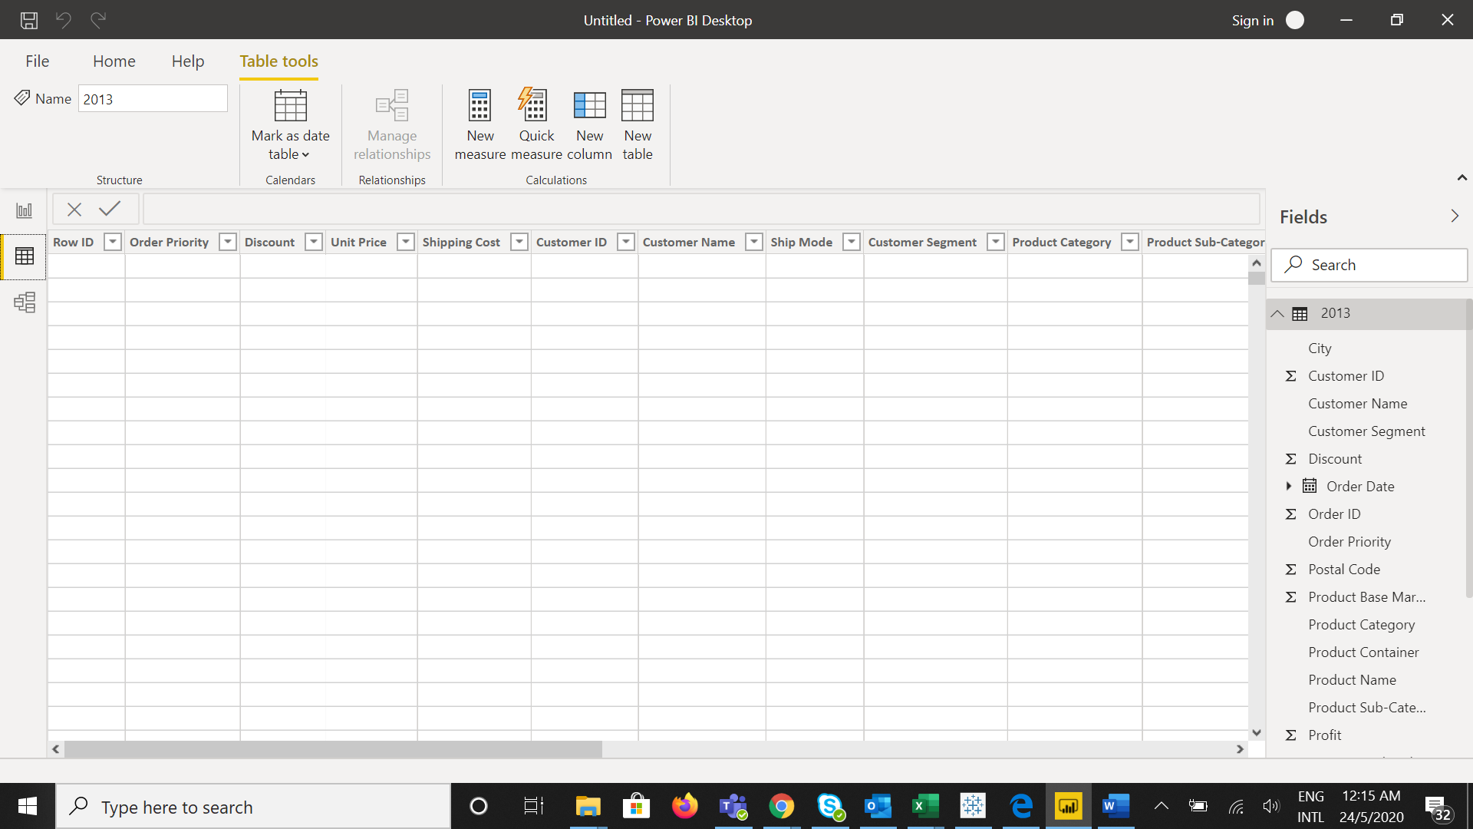

**− Model View**

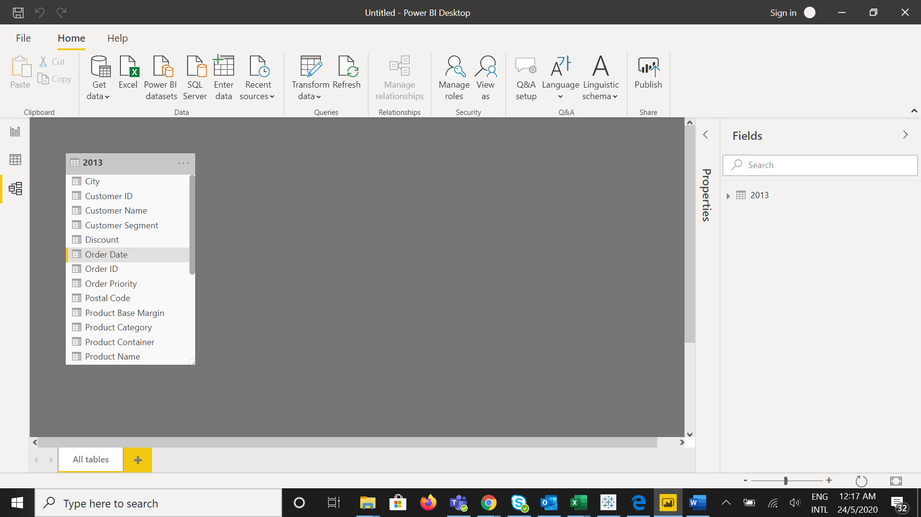

**− Power Query Editor**

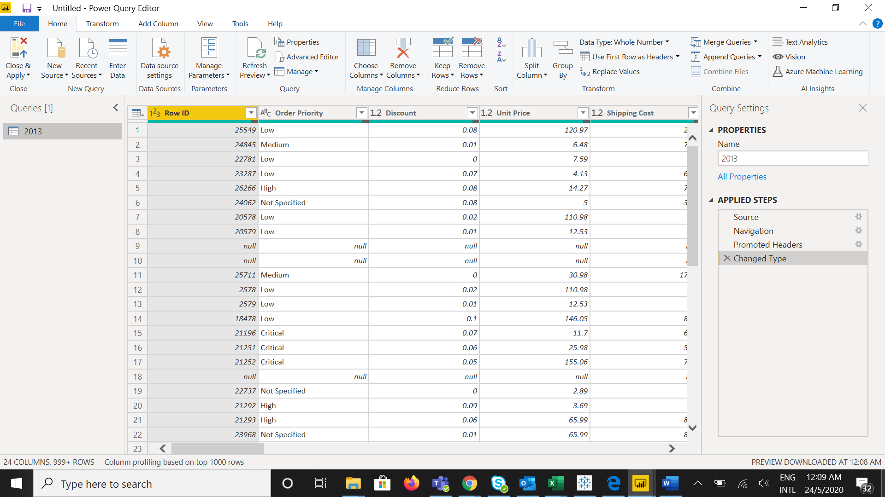

**− Advance Editor**

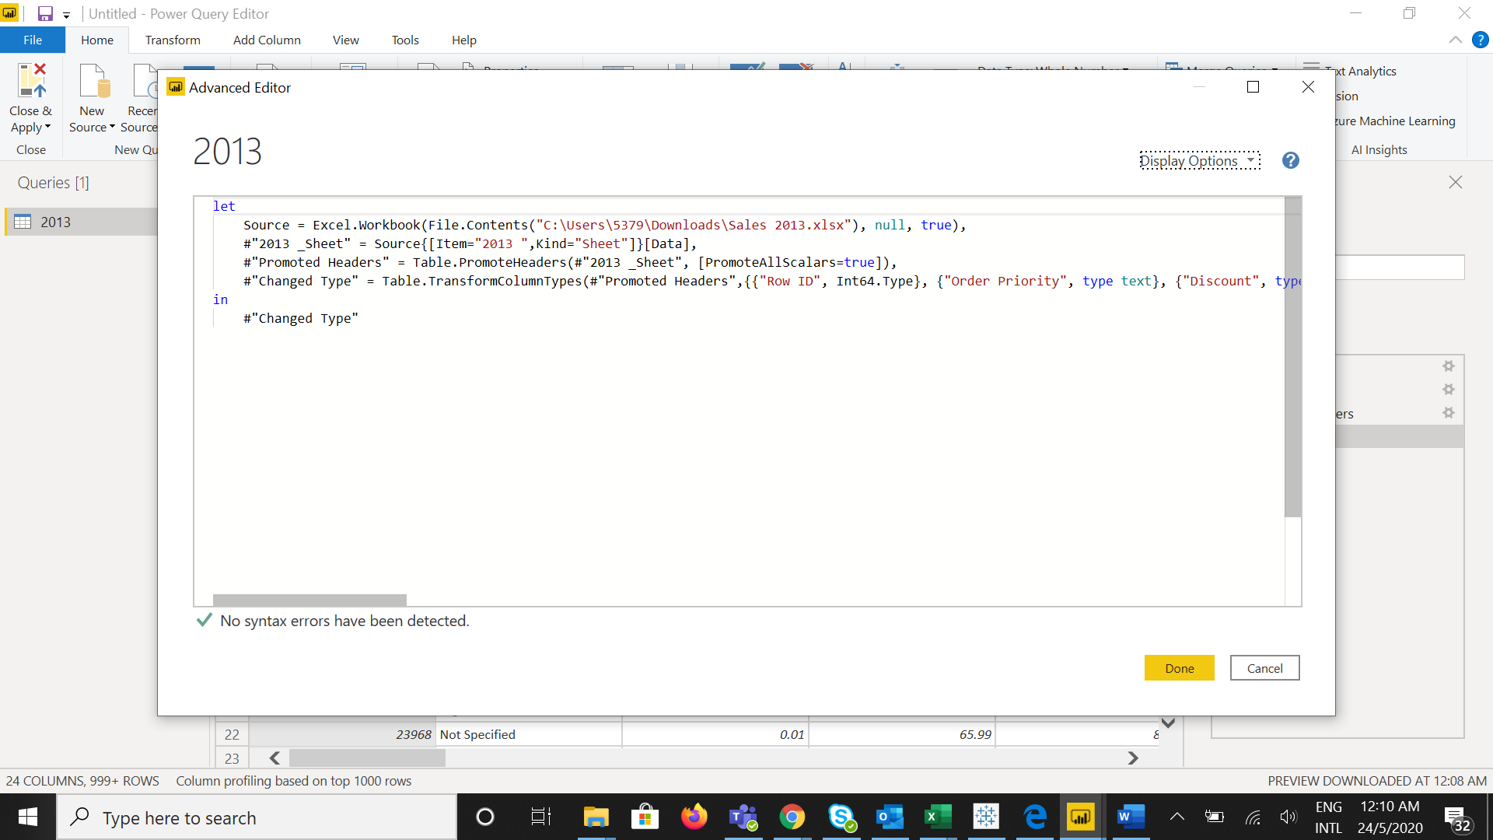

• Prepare a document with details of the following along with their price

**− Power BI Desktop**

Power BI Desktop is a free application you install on our local computer that lets us connect to, transform, and visualize the data. With Power BI Desktop, we can connect to multiple different sources of data, and combine them into a data model. This data model lets you build visuals, and collections of visuals you can share as reports, with other people inside your organization. Most users who work on business intelligence projects use Power BI Desktop to create reports, and then use the Power BI service to share their reports with others.

Price – Free

**− Power BI Pro**

Power BI Pro is an individual user license that lets users read and interact with reports and dashboards that others have published to the Power BI service. Users with this license type can share content and collaborate with other Power BI Pro users. Only Power BI Pro users can publish or share content with other users or consume content that's created by others

Power BI Pro Price is - $9.99 user/month

**− Power BI Premium**

Power Bi Premium gives more consistent performance and larger data volumes, without requiring to purchase per-user licenses.

It also offers advanced, self-service data preparation that allows every user from business analyst to data scientist to accelerate the delivery of insights and collaborate with ease.

The price of Power BI Premium is - **$4,995** Monthly price per dedicated cloud compute and storage resource with annual subscription.